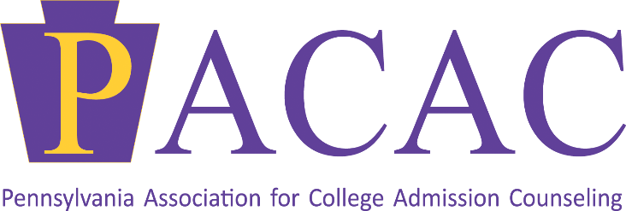

58th Annual Conference
Special Interest Group Discussions
Monday, June 28
8:00 AM- 8:45 AM

Diversity, Equity, and Inclusion
Host(s): Joni Klopp, Assistant Director of Admission, Millersville University & Dana Martin, College Advisor, Mastery Charter Schools – Lenfest Campus
The mission of the Diversity, Equity and Inclusion Special Interest Group is to support PACAC’s mission of promoting DEI throughout programing, resources, and other opportunities. It fosters discussions around issues college admission counseling professionals face, how to better serve students and families, and provide emphasis to awareness and discussions related to topics, issues, and trends relevant to Diversity, Equity, and Inclusion in college admission counseling.

Rural and Small Town Recruitment
Host(s): Ian Harkness, Director of College Counseling, Malvern Prep & Justin Mohney, Associate Director of Admission, Carnegie Mellon University
The Rural and Small Town Recruitment SIG mission is to bring rural and small town admission and college counseling professionals, as well as those committed to rural and small town education, together to increase college access, success, promote college-going culture in rural areas, and support counselors and students at rural and small town schools.

Community College & Transfer Students
Host(s): Amber Moore, Assistant Director of Admission and Enrollment Services, Delaware Valley Community College & Katie Jordan, Assistant Director of Admission and Transfer Admission Coordinator, Allegheny College
The community college and transfer student special interest group is designed to engage people in discussion about the unique issues facing community colleges and transfer students. These discussions will allow college admission counseling professionals to better serve, counsel and support this populations of students for success.

Independent Educational Consultants
Host(s): Stacey Cunitz, Blue Moon Educational Consulting
The independent educational consultant SIG allows all educational consultants not affiliated with schools or colleges to come together to share common issues, including ethical practices, support for students in the college admission process, and emerging issues of concern for our group as well as the greater PACAC audience.

Tuesday, June 29
8:00 AM- 8:45 AM

Regional Admission Counselors
Host(s): Candice Duckworth, Associate Director of Regional Recruitment, University of Vermont
The mission of the Regional Admission Counselor Special Interest Group is to support the vast and growing number of admission counselors that serve their institutions as remotely-based members of their admission team.

Secondary School Counselors
Host(s): Karen Rubican, School Counselor, Canon-McMillan High School & Jennifer Kirk, High School Counseling Curriculum Leader/PSCA Board Chair, Upper St. Clair High School
The mission of the Secondary School Counselor Special Interest Group is to support the work and aspirations of college counseling professionals working with students and families. The group will discuss rising issues, challenges, and opportunities to better support and serve their students.
Community Based Organizations
Host(s): Christen Johnson, Director of Outreach and Engagement, Philadelphia Futures
The Community Based organization special interest group is a forum for the discussion of, advocacy for, issues that impact community based organizations and the students with whom they work with. This group will provide a platform for open discussion, ways to support and best serve these students, and a space to create outreach opportunities.

